**REPORT**

**OF**

**MY PERSONAL CDS PROJECT**

**ON**

**DRUG ABUSE**

**AT**

**BAUCHI LGA**

**BY**

**ADEOYE RUTH ADENIKE**

**BA/19A/1221**

**EXECUTIVE SUMMARY**

Adeoye Ruth Adenike, a serving corp member posted to Hospital Management Board, currently serving at Infectious Diseases Hospital, Bayara, Bauchi State with the State code BA/19A/1221 carried out an awareness creation and sensitization programme on Drug Abuse, its consequences, prevention and treatment among young people (a global issue which is becoming a rising event among young people based on the research carried out by United Nation Office of Drugs and Crime (UNODC) during the influencer workshop by MTN Foundation attended by me in Bauchi months ago). The awareness creation and sensitization programme which was done through various medium started on the 3rd of November, 2019 with the media sensitization session which took place at the Al-barka FM and Bauchi Radio Corporation (BRC) every Saturday by 5:30pm to 6:00pm and every Monday by 3:00pm to 4:00pm respectively for the month of November, 2019.

The school sensitization/talk and interactive session which covers 10 senior secondary schools (7 government schools and 3 private-owned schools) started on the 12th of November, 2019 at General Hassan Kastinah Unity College and Government Day Comprehensive Secondary School, Bakari Dukku, followed by Dr Ibrahim Tahir Comprehensive Secondary School, Government Day Comprehensive Secondary School Za’adu Zungur, Iqraa Science Academy, Jibril Aminu Secondary School, Havardth International School, Al-Bulshra International, Government Day Comprehensive Secondary School, Shadawanka Barrack, and Sky Crest Academy.

The program which had direct impact on not less than 1500 young people and its expected indirect impact on not less than 500 young people had in attendance management staff of the various schools, Dr Simeon Ategbese, a Mental Health Physician of Abubakar Tafawa Balewa University Teaching Hospital, Bauchi State, Dr Pollum Babangida, the Chief Medical Director of Infectious Diseases Hospital, Bayara, Dr Peter Ajanson, a Physician from University of Maiduguri Teaching Hospital, Maiduguri, Publicity and Editorial CDS President, Mr Yunusa Abdulsalam, Young African Leaders Initiative Network (YALINetwork Bauchi hub) representative Miss Kairat Ibrahim Miss Abubakar, Yersmeen Ibrahim Abubakar, and Mr Abiodun Hameed and my efficient team members; Dorcas Ariomerebi, Alimi Uthman Adedolapo, Fedrick Etiosa, David Samuel, Emmanuel Joel, and Olamide Oyeyemi.

**BACKGROUND**

From the recent update by United Nation Office on Drugs and crime [UNODC] in June 26, 2019, report shows that 15% of adult in Nigeria are reported with a considerable level of use of psychoactive drug substance. 14.4% are drug users with 14.3m between ages 15-64 years. 35m of people worldwide are suffering from drug use disorder. Higher level of drug abuse is being recorded compared to the precious report of 5.6% in 2016. Drug abuse rate much higher than before on a daily basis.

According to the report from a consultant psychiatrist with the Abubakar Tafawa Balewa University Teaching Hospital Bauchi, 8 out of 10 patients brought to mental health clinics of the hospital are youth, who abused drugs. Drug abuse among youth has increased suicide rate. Many at the age of 14 already into drug abuse due to one reason or the other, with many of the cases going undetected.

That is why we l created awareness using various medium like media sensitization and school outreaches. Drug abuse prevent an individual to engage in productive ventures.

**INTRODUCTION**

Drug Abuse: A Growing Global Health Challenge awareness creation and sensitization program was organized by Adeoye Ruth Adenike, a serving corps member in Bauchi state to highlight the dangers of drug use and their illegal trade and provides the students with adequate and current information on drug abuse to help spread this message about the extreme cultural and economic harm the trade in drugs is still doing on individuals, families, communities and across the globe one hundred years after the war on drug was initially launched, to this I organized a programme to combat the increasing rate of drug abuse through educational and health awareness, sensitization and interactive session.

Studies show that, improved awareness on the behavioral risk factors of drug abuse among secondary school students in the school community can improve sound health, increase productivity in school as a student and ultimately prolong life. Thus, preventing their onset and progression will go a long way in preventing NCDs, ill health, failure, drop-out rate among students, promoting student’s health and hence prolong life. Therefore, preventing and controlling this rising prevalence of drug abuse in the student community is essential.

**PROJECT OBJECTIVES**

* To improve the student’s knowledge about drugs, its abuse, negative effects on health and preventive measures.
* To enhance good behavioral factors that will improve health rather than put health at risk among the students.
* To reduce the increasing rate of substance abuse among young people.

**HIGHLIGHT**

The media aspect of the sensitization program was divided into four (4) sections with personnel responsible for each on different days.

The introductory aspect of the media program was done by Miss Adeoye Ruth Adenike, who sensitized Bauchi people at Bauchi Radio Corporation (BRC) and Al-barka FM. She talked about the program, the caption; Alive, Healthy and Productive. She explained what drug is all about, what it means to abuse drug, examples of commonly abused drugs, reasons why people abuse drugs, its classification, stages, and social problems of drug abuse, its danger, risk factors and preventive measures.

Dr Peter Sule Ajanson, a Physician from University of Maiduguri Teaching Hospital, Maiduguri, facilitated the second session of the program. He sensitized the populace on the consequences of drug abuse, commonly abused drugs, effects of drug abused, ways in which drugs are abused. He concluded his sensitization with the word “People who abused drugs tend to lose their job more than people who are not into drugs”

The third section was facilitated by an erudite of knowledge, a seasoned physician, a medical director of Infectious Diseases Hospital, Bayara, Dr Pollum Babangida, she address the reproductive health implications of drug abuse, negative consequences of drug abuse, and why it seems difficult to stop drugs when addicted to it. She dropped the curtain on the keynote that “Until we see drug abuse as a disease and not a crime, there can’t be a complete solution nationwide or globally”.

A seasoned mental health physician from Abubakar Tafawa Balewa University Teaching hospital, Dr Simeon Olayinka Ategbese. He wrapped up the media section of the program with the topic “Drug Addiction and Dependence: A Threat to Health. He explained that drug dependence are of three (3) categories which are: Tolerance.

Craving.

Withdrawal.

He explained the criteria for drug dependence, effects of drugs dependence to be categorized into four (4) which are: Physical.

Psychosocial.

Social.

Psychological.

He explained the mental and behavioural disorder, the way forward and the preventive measures to be taken into be of three categories: Primary prevention.

Secondary prevention.

Tertiary prevention.

He finalized the section by noting the treatment options for those with drug dependence, he made it known that there are various treatment models and evidence does show that there is no single treatment that works for everyone, and some treatment are more effective than others.

He dropped a keynote that “Investment in treatment programmes can yield significant returns such as reduced drug related crime and improved health outcomes.”

The school sensitization outreaches was done in ten (10) senior secondary schools where I sensitized the students and staff of each senior secondary schools with the use of Drug Free World and UNODC Information Education and Communication (IEC) materials.

Names of schools visited for the sensitization outreach:

1. General Hassan Kastinah Unity College.
2. Government Day Comprehensive Secondary School, Bakari Dukku.
3. Dr Ibrahim Tahir Comprehensive Secondary School.
4. Government Day Comprehensive Secondary School Za’adu Zungur.
5. Iqraa Science Academy.
6. Jibril Aminu Secondary School.
7. Havardth International School.
8. Al-Bulshra International.
9. Government Day Comprehensive Secondary School, Shadawanka Barrack.
10. Sky Crest Academy.

Miss Adeoye Ruth Adenike explained that drugs are natural synthetic chemical substances which can affect the body and its processes, the behaviour and feelings. She made it known that some drugs have medical purposes but many drugs are illegal and are extremely dangerous. Legal drugs like alcohol and prescription medications can also be dangerous if misused. Even in small amounts, drugs can create big problems because it’s not always possible to predict how a drug will affect the user or the user’s life. She explained to the students and staff that drugs can cause:

* Damage to health – drug-related injuries, physical illness among others.
* Financial hardship
* Trouble with the law – being convicted of a drug-related crime can seriously disrupt a person’s life.
* Social difficulties – trying to work out their problem, people try to run from their problems by using drugs. This usually makes the problem worse, and even create new ones.

Drug users often end up with serious problems, they may:

* Get sick: loss of resistance to disease and harm their health. Intravenous drug users may be exposed to AIDS and other serious diseases.
* Have accident: drugs can impair driving ability and make users less concerned about personal safety.
* Become “hooked”: continuous use of drugs can lead to a physical and/or psychological dependence.
* Go to jail: possession of illegal drugs is punishable by prison sentence.
* Commit crimes: stealing is a means of supporting an expensive habit.
* Become violent: certain drugs can trigger violence against others.
* Be arrested: an NDLEA record can follow users through life, eliminate certain career choice, etc.
* Lose friends: once a user is hooked with drugs, it becomes more important than anything else, including friendship and family.

She made it known to the students and staff reasons why many young people turn to drugs, which are:

* Some young people think to experiment with drugs is harmless. Anytime drugs are being abuse, you raise your risk of physical injury. And no one can tell how soon you could become addicted.
* Peer pressure: some start drug use because their friends are using drugs and they want to belong so they won’t be odd and make jest of by friends.
* Loneliness: trying to escape feelings of loneliness, some people use drugs which cut them away from other people. Drug users’ ends up feeling more isolated and alone than before.

She took her time to explain the five (5) basic kinds of drugs for their better understanding of each drug classification and effects. The drugs kinds are:

1. Stimulants: speed up the nervous system. Examples are Amphetamines, Cocaine, Crack/Rock, Nicotine, and Caffeine.
2. Depressants: slow down the central nervous system. Examples are Barbiturates, Tranquilizers, Methaqualone, and Alcohol.
3. Hallucinogens: changes in perception and consciousness. Examples are Lysergic acid Diethylamide (LSD acid), Phencyclidine (PCP), Mescaline, STP etc.
4. Narcotics: lower perception of pain. Examples include Heroin, Morphine, Opium, Codeine, Meperdine, methadonae etc.
5. Cannabis: affect thinking and behavior. Examples include Marijuana and Hashish.

Some facts about drugs:

**NOTE:** depressants taken in combination such as alcohol plus barbiturates are even more dangerous. They can cause coma and death.

**GENERAL HUSSAN COLLEGE**

Mr Levi Siman (Guidance and Counsellor) addressed the student stating that drugs are not made here, they are imported from other places and sold here, and they cultivate and plant things that they do not take. They are trying to kill us by killing our brains. Have you ever seen a drug addict paying attention in class? Do you see drug abuse driving cars or working in offices? No its typical NO. Some people take drugs and split wood, not knowing that they can work in offices or go to school with the time they waste unconsciously splitting wood. So I would like you to make your life better and shun Drugs because they are very harmful to the society.

**Teachers Present**

-Idris Garba

-Abdulwahab Muhammed Magaji

-Yusuf Jamiu

-Mr Levi Siman (Guidance and Counsellor)

-VP Academics

-Principal

**GOVERNMENT COMPRENHENSIVE DAY SECONDARY SCHOOL BAKARI DUKKU**

**DEBATE**

**Supporting –** Aishat Abdullahi SSII B

-Muhammad Bashii Ayuba SSIII A

-Maryam Aliyu Muhammed SSII B

**Opposing -** Rukayat Abubakar SSIII B

-Abdulrazak Sarri SSIII A

-Fatimah Aliyu SSIII C

-Definition of drug abuse

-Health consequences - lung and heart disease

- weakened immune system

- decrease strength of the liver

-Reasons why young people take drugs –to feel good

**Success Stories** -Raft attention

-School management interested and gladly received me and requested for

establishment of drug free club in the school for sustainability.

-They requested for more programs to be done in their school.

-Accepted of erection of signboard in the school premises.

-Collaboration for further help

**Challenges** -Unavailability of pre-test and post-test question to access the level of thee in

knowledge of the students on drug abuse.

-Time: convident standard appointed time 2pm because they had to go for prayer.

**Guest Speakers -**Dr Simeon Ategbese

-Publicity CDS President- Yumusa Abdulsalam

-Yali representative -Kariat Ibrahim Abubakar

-Yersmeen Ibrahim Abubakar

**DR IBRAHIM TAHIR C.S**

**Staff Names -**Principal Mrs Saadatu

-VP academics Mrs Ladi Muhammed

-President Yunusa Abdulsalam

-Class Teacher Mr Abdul Ahmad

Mrs Rabiatu Muhammed

**Debates**

**Opposing -**Ahmad Abdullahi Shehu SSII A

-Ahmad Umar Shehu SSII A

**Supporting** -Abdurasheed A.Gwani SSIII A

-Halima Abdullahi SSIII B

**Ahmad**

-Defined drug

-stated the reasons why young people go into drug abuse and stated the most obvious effect of drug abuse

- Death, coma, HIV, Hepatitis through infection.

**Aishat**

-Effect neurotransmitter

-Affect not just user but family and friends

**Opposing**

-Tramor makes you to work like a machine.

-Statistics state shows that 50% of this drug causes addiction since is addictive, it is not good and strongly oppose taking of drug abuse.

**Ahmad Umar Shehu**

-Has more effect on youth

-Taken who prescription

**Drama**

-Ismail Bala Idris JSS3 A

-Usman Yakubu Ladan JSS3 A

-Maryam Abdullahi Launi JSS3 A

-Hafsat Abubakar SS2 A

-Nurudeen Muhid Sari SS2 D

**Contribution / Questions**

**-**Lukman -Ahmad –Umar

Ahmad Abdullahi –Is it true that the drugs taken to be active for work really works in the body.

Auwal Abdullahi SSII A –Meet orientations agencies to show them alternatives than using drugs

Ossama Adamu SSII E –Passive smokers, are they also affected? Does that mean is bad?

Aishat Abubakar SSII A –Shisha is taken as a means of medicine, is it good for their health?

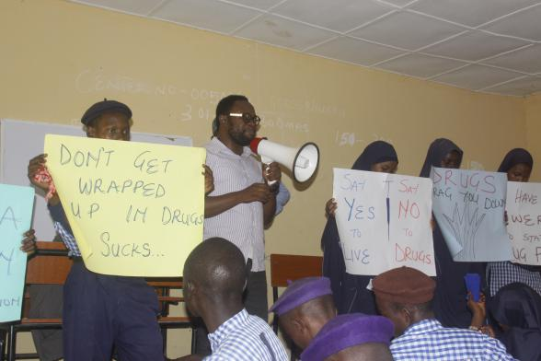**APPENDIX**

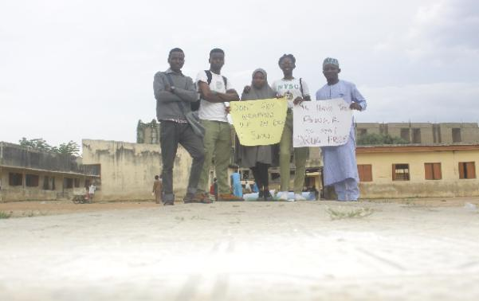

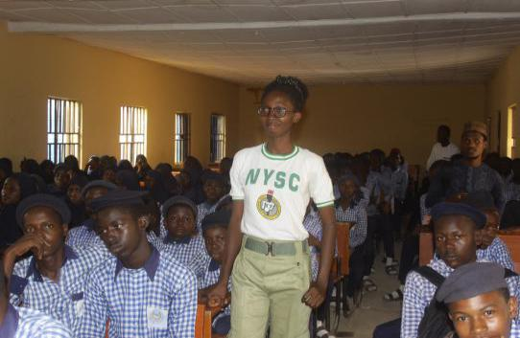**Team members**  **Dr Simeon Ategbese sesitizing the students**

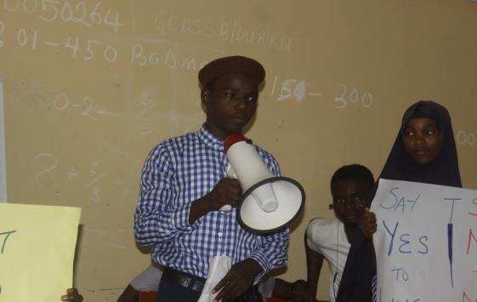

**Team lead Debate session by the students.**

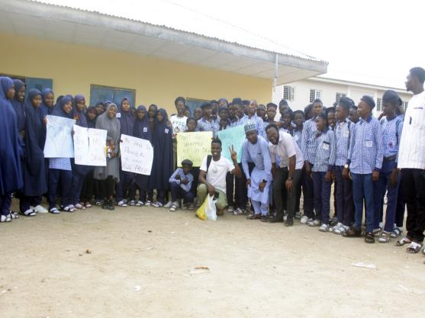 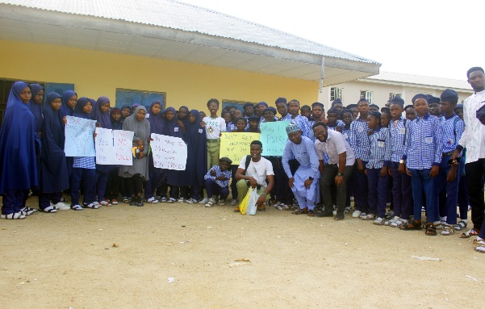

**Student, staff and team members at GDSS Bakaridukku.**

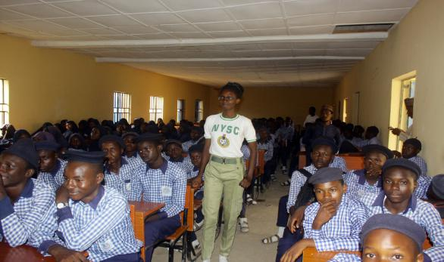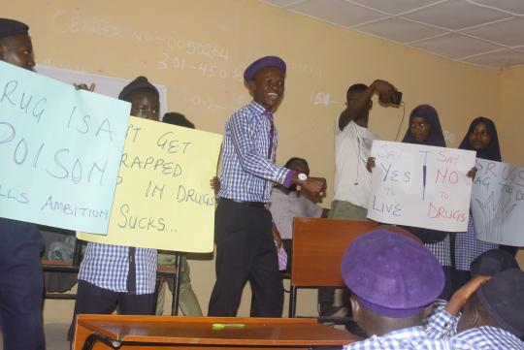

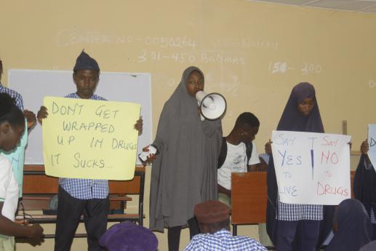 **Debate session**

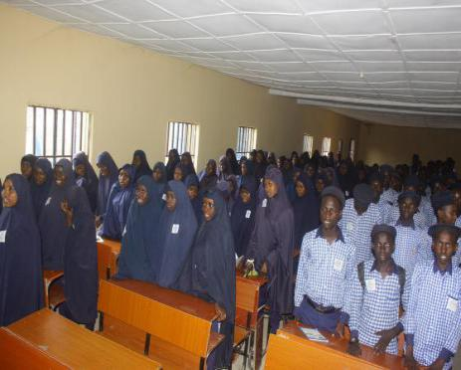

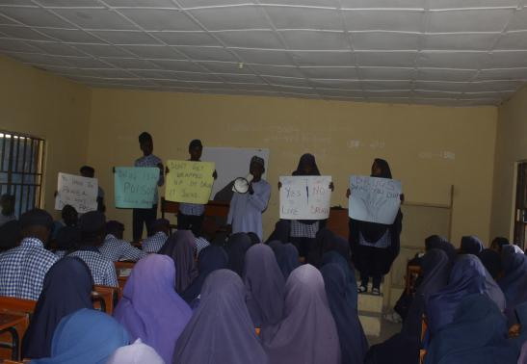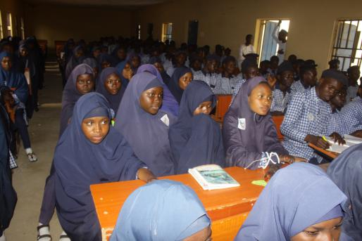

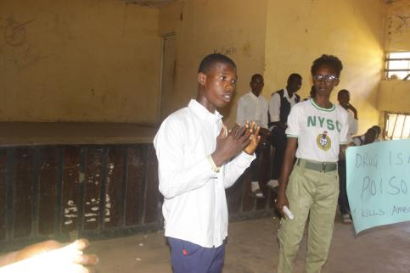 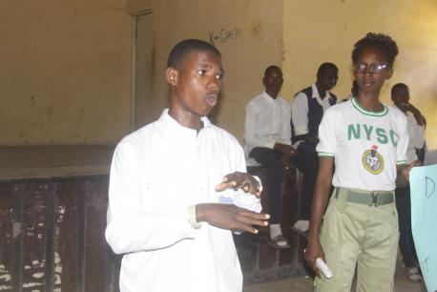

**Debate session at General Hassan College, Bauchi.**

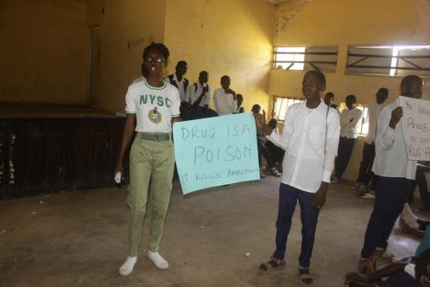 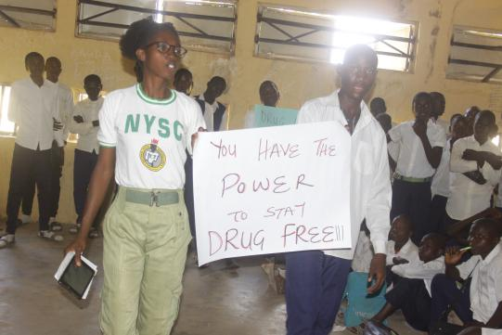

**Discussion session by the project initiator at General Hassan College.**

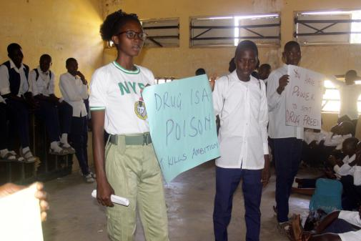 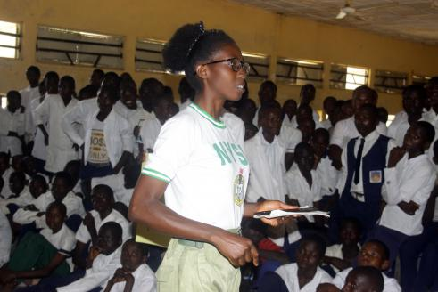

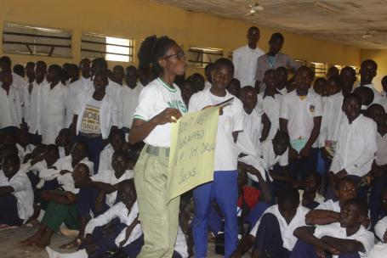 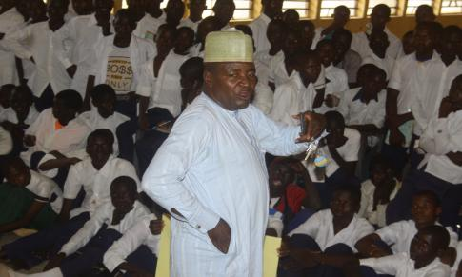

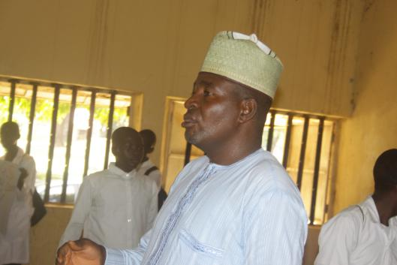**Mr Levi Siman counselling the students.**

